CONFERENCE REGISTRATION NOW OPEN!!
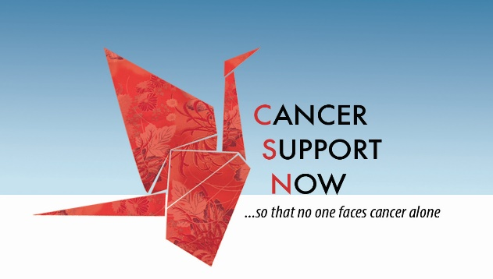
Cancer Support Now
11th Annual Living with and Beyond Cancer Conference
Saturday, April 9th 9:00am –3:30pm

Name / Nombre

Phone / Número de teléfono

Mailing address / Dirección de envío

Email / Correo electrónico

Are you a caregiver? / ¿Eres proveedor de cuidados? YES / SI NO
Are you a cancer survivor? / ¿Eres sobreviviente de cáncer? YES / SI NO
Are you a health professional? / ¿Eres profesional de la salud? YES / SI NO

FREE Virtual Conference, Registration Required by April 2nd
In order to participate, download the free Zoom app to your computer or smart phone. Prior to the event, you will receive an email with a link, which you will allow you to access the conference at 9:00 am on April 9th.
See website for more information about each speaker/topic.

Registration Required:
This form is available to Register online at www.cancersupportnow.org, OR download the registration form, complete it, and mail to us at Cancer Support Now, Inc., PO Box 37338, Albuquerque, NM 87176 OR call and leave a message for Valerie at 505-265-9000 with your name & phone number
SPONSORED IN PART BY:

